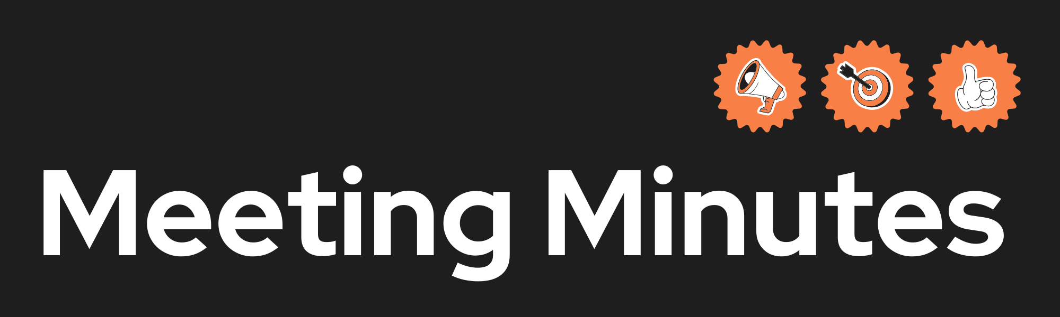
Date and Time | Date: 20/2/2026  Time: 11:00am – 2:00pm (3 hours)
Project Name | Bare Minimum legends
Meeting Goal | - Discuss Sprint 2 requirements and tasks
Facilitator | Narcis
Note taker | Narcis
Attendees | Renato, Yuhang, Pakize, Khrystyna, Narcis
Roundtable Updates (each group member to contribute) | Renato – started to look at wire frames users stories  Khrystyna – Looked at colour scheme fonts also user stories
Discussion points | - Wire frames completation and handing out to members(draw.io)  - User stories  - Week 2 requirements  - Logo  - Case diagram  - Visual identity  - Sequence diagram  - Next meeting will attend
Actions (list tasks and assign a group member) | -Narcis, wire frame – Video page, about us  - Renato, user stories, case diagram  - Yuhang, wire frame – competitions/ team finder, sequence diagram  - Khrystyna wire frames – guides page, guide details, logo  - Pakize – wire frame )profile)

